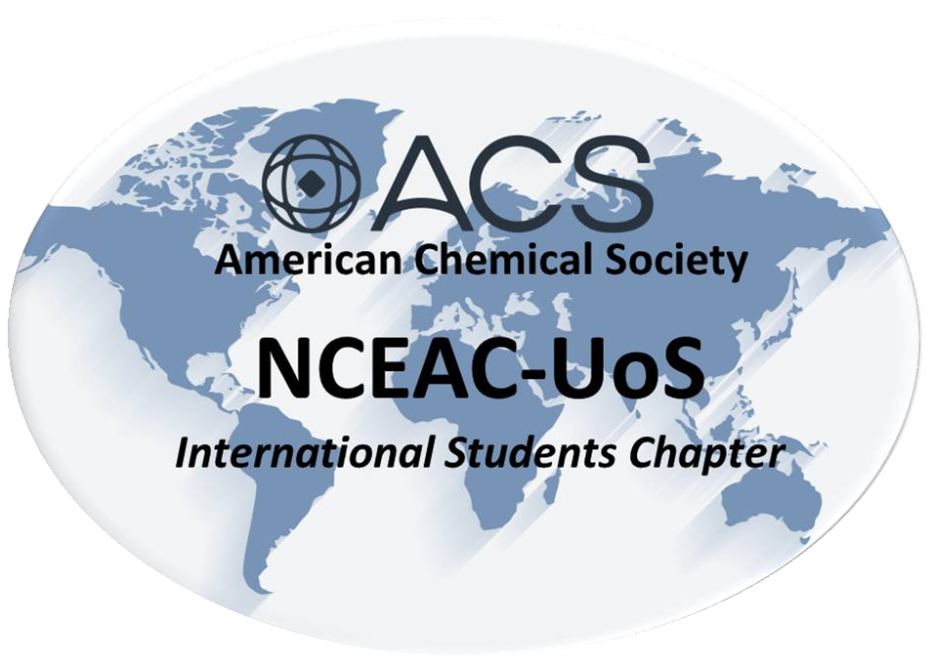

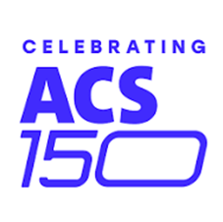
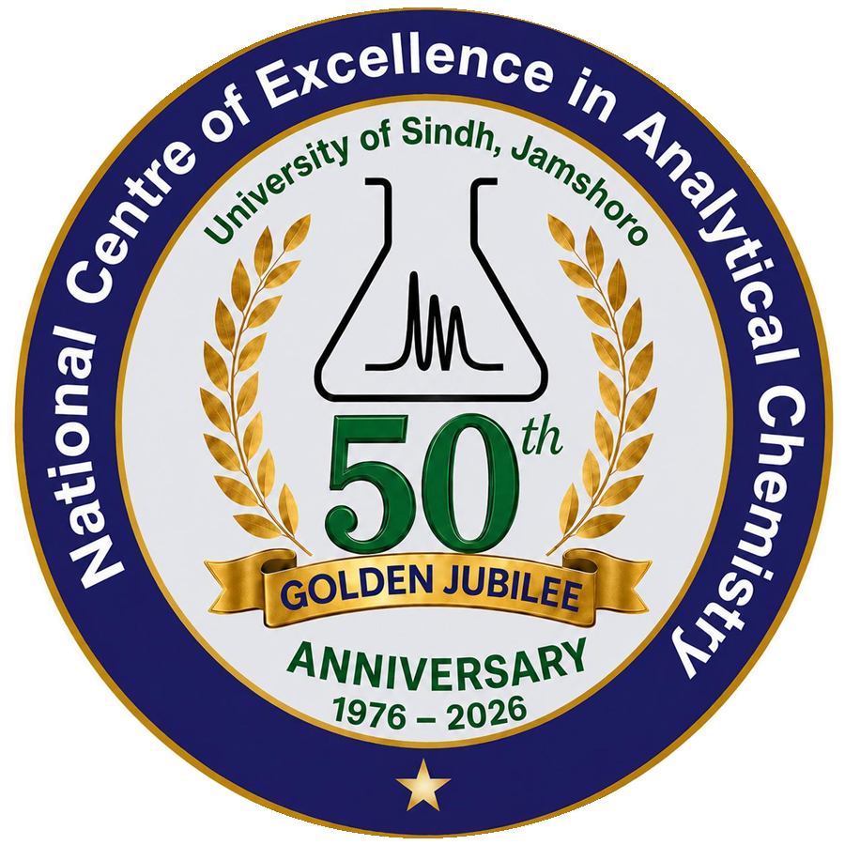
NATIONAL CENTRE OF EXCELLENCE IN ANALYTICAL CHEMISTRY
UNIVERSITY OF SINDH, JAMSHORO

ABSTRACT SUBMISSION TEMPLATE
Poster Presentation Competition | NCEAC @ 50 & ACS @ 150
“Innovating for a Greener Future: Green Chemistry Solutions for Sustainable Development”
COMPETITION DATE: 26th NOVEMBER 2026 | ABSTRACT LIMIT: MAXIMUM 300 WORDS

INSTRUCTIONS: Complete all fields. Submit the abstract in English and in Word format through the Google Form. The abstract must be original, plagiarism-free, and free of overstated claims. Use the headings provided below: Background/Objective, Methods, Key Results, and Conclusion. Select one primary competition theme and include 3–5 keywords.

NCEAC-UoS/ACS26-PP-00

Paste relevant SDG here

1. TITLE, AUTHORS AND AFFILIATIONS
Abstract title (concise and specific; use title case):
[Type your abstract title here]
Author(s): [Full name of author 1], [Presenting author], [Full name of author 2], [Full name of author 3], ...
Affiliations: [Department/Institute, University/Organization, City, Country; use superscript numbers to link authors to affiliations if needed]
Corresponding email: [Provide a valid email address]

2. PRIMARY COMPETITION THEME
Select ONE primary theme and state the same theme on your poster:
☐ 1. Green synthesis and sustainable catalysis | ☐ 2. Green solvents and reaction media
☐ 3. Renewable feedstocks and biomass valorization | ☐ 4. Green nanotechnology and nanomaterials
☐ 5. Sustainable agriculture and agrochemicals | ☐ 6. Environmental remediation and clean water
☐ 7. Clean energy and energy storage | ☐ 8. CO₂ capture, utilization, and climate mitigation
☐ 9. Waste minimization and circular economy | ☐ 10. Computational and data-driven green chemistry
☐ 11. Green analytical chemistry and sensors | ☐ 12. Sustainable materials, polymers, and textiles
☐ 13. Green pharmaceuticals and medicinal chemistry | ☐ 14. Policy, education, and industrial adoption

3. ABSTRACT (MAXIMUM 300 WORDS)
Background / Objective
[Briefly introduce the research problem, its significance, the knowledge gap, and the specific objective(s).]
Methods
[Summarize the materials, methods, experimental/computational approach, and key procedures.]
Key Results
[Present the most important findings. If the work is ongoing, clearly identify preliminary results or expected outcomes; do not overstate claims.]
Conclusion
[State the main conclusion and explain the contribution or significance of the work for green chemistry and sustainable development.]

4. GREEN CHEMISTRY AND SUSTAINABILITY RELEVANCE
Green Chemistry principles addressed (name at least TWO): [e.g., waste prevention, safer solvents, energy efficiency, catalysis, renewable feedstocks, design for degradation]
Relevant UN Sustainable Development Goal(s): [e.g., SDG 6, SDG 7, SDG 9, SDG 12, SDG 13]
Green metric/evaluation (where relevant): [e.g., atom economy, E-factor, solvent choice, energy use, biodegradability; provide a value or brief explanation if available]

5. KEYWORDS (3–5)
[Keyword 1]; [Keyword 2]; [Keyword 3]; [Keyword 4]; [Keyword 5]
WORD COUNT (abstract text only): 300 words
AUTHOR DECLARATION

I confirm that this abstract is original, that all contributors are appropriately acknowledged, and that my supervisor has approved the submission. I understand that the abstract will be reviewed by the organizing committee.
Presenting author's name: ______________________________ Date: __________________

